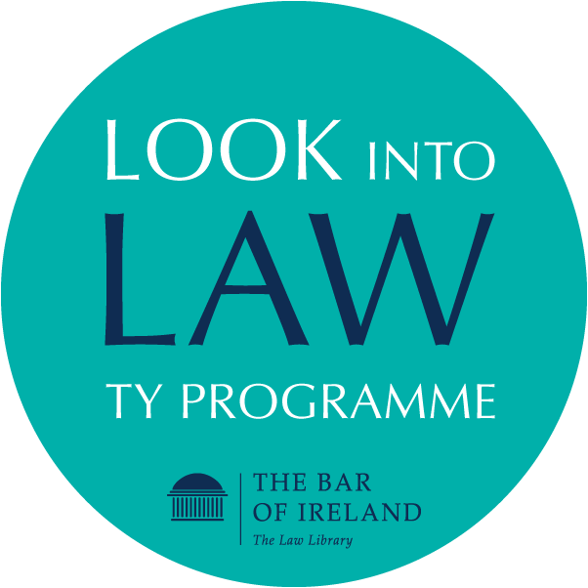**Module 1:**

**Questions and answers to the Independent Bar Knowledge Check**

1. Can a lawyer be both a barrister and a solicitor at the same time?

Yes

**No**

Sometimes depending on the type of case

2. How does a barrister get involved in a case?

The client engages a barrister directly

**The client engages a solicitor who then instructs a barrister**

The client engages a barrister who then instructs a solicitor

The client engages a solicitor and a barrister directly

3. A solicitor and a barrister have a right of audience in court:

**True**

False

4. Barristers work in a partnership with other barristers:

True

**False**

5. Why are some of the primary standards that Barristers in the Bar of Ireland must uphold?

Funny, Smart, Independence

Integrity, Witty, Independence

**Independence, Integrity, Expertise**

There are no standards as barristers are self-employed.

6. What is the CAB rank rule?

Only a rich person can access a barrister.

**A barrister is obliged to accept instructions from all members of the public.**

Only an innocent person can access a barrister.

A barrister can choose the client.

7.  Why is the CAB rank rule important?

To allow barristers get taxis cheaper into court.

To allow members of the public to get cheaper taxis to court

**To ensure that every member of the public can access justice with the assistance of a barrister.**

To ensure that a barrister is kept busy in work

7. Barristers can lie to the court when:

Their client is at risk of being imprisoned

Their client instructs the barrister to lie.

Their client pays the barrister extra money.

**Never – a barrister can never mislead the court for any reason.**

8. In general, what does it mean for a barrister to have “integrity”?

A barrister must be honest.

A barrister must adhere to moral principles and values.

A barrister must adhere to ethical principles and values.

**All of the above**

**Questions and answers  – President Kelly, District Court - Knowledge Check**

1. **You have to be a barrister to become a judge** – False [President Kelly practised as a solicitor before becoming a judge]

1. Where did President Kelly first sit as a Judge?

**Donegal**

1. **He was appointed as President of the District Court in**

**March 2021**

March 2020

May 2021

1. **What expression does the President use about the District Court? He says it’s the ____________ of the Irish court system.**

1. **How many matters does the District Court deal with in a year?**

**55,000**

**550,000**

**5,500**

1. **Almost all criminal cases in the State start out in the District Court.** – True
2. **President Kelly mentions quite a few people you will see in court.** Which of the following does he not mention:

Gardai

Probation service

Court registrars

**Judicial assistants**

Social workers

**Questions and answers to Life as a Devil Knowledge Check**

1. **What broadly is the type of work you will be doing with your master while devilling?**
2. Research, drafting of pleadings, making applications before the court in respect of their cases, shadowing them at consultations and settlement meetings.
3. **What is the name given to the barristers that have devilled for your Master in previous years?**
4. Your devil family

1. **What are the names of the two officers of the Court who deal with the vast majority of Motions?** The County Registrar in the Circuit Court, and the Master in the High Court.

1. **On what basis, is the order for dealing with Motions by consent based?** The order for dealing with consent Motions is based on seniority among barristers, based on their year of call to the bar.

1. **What is the name of the ceremony students experience in the Supreme Court?**Call to the Bar

1. **What is the term for the apprenticeship which Barristers must participate in?** Devilling

1. **When does the legal year begin/end?** 1st Monday of October and 31st of July

1. **How many year(s) is it mandatory to devil?** 1 year